Omagh Methodist Church
Reception Service 1966

The photograph below appeared in the Tyrone Constitution some months ago.
Following review by the “News & Views” Team from the early 1990’s we have come up with a good number of the names in the photograph. We are adding it now to the “Memories” section of the OMC Website and the invitation is to all to try and complete the names of those in the photograph.
Please do take a bit of time to study the photograph and if there are any folk you recognise, yet unnamed below, please let one of us know.

Esther Stewart esther_44@hotmail.co.uk
Desmond Preston desmondpreston@hotmail.com
John Buchanan johnsbuchanan2@hotmail.com
May 2020

Photo OMC 966
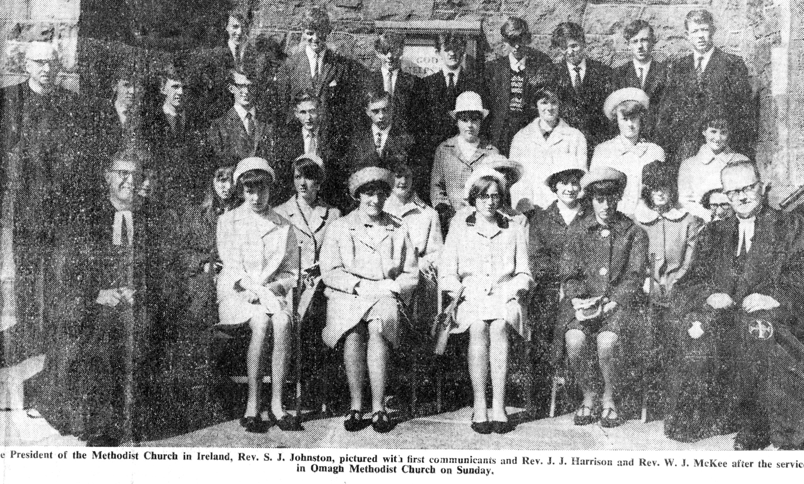

Back Row
Erville Millar David Kyle Ewing Kenny Alcorn Dennis Harkness ___________ __________ Desmond Preston
Wesley Preston

2nd Row
Rev McKee John Buchanan Billy Reynolds Dewar Twist _________ __________ ________ Ruth Armstrong
Joy Aiken Joan Harkness

3rd row
__________ __________ Noleen Johnston __________ __________ __________ __________ Shelia Russell

Front row
Rev Harrison ___________ Barbara Brown Elizabeth Blackwood Joan Alcorn Rev S J Johnston (President)

Other possible names for consideration:

Ann Clarke; Eileen McBratney; Noel McBratney; Linda Davis; Florence McConnell; Basil Aiken; David Aiken;

Reggie Aiken; Wesley Beacom; Boy Shields; Girl Shields; Kenny Johnston; Ken Robinson; Dale Robinsion; Ann Moffitt; Gavin Bann;

Moffitt children??

