From Gerry Knight’s photograph album – set 2
Such was the interest in his first set of photo memories that Gerry compiled that he has put together a second set of five [scroll down to see them all]. He hopes these pictures will stir some happy memories. As with many old photos it is hard to remember when and where they were taken and who is in them. With regard to the photos below, if anyone can provide more information about “the when, “the where and the who” please contact either Gerry or Jim.
Photo No. 1: Omagh MWA in 1982 on the steps at Omagh Methodist Church
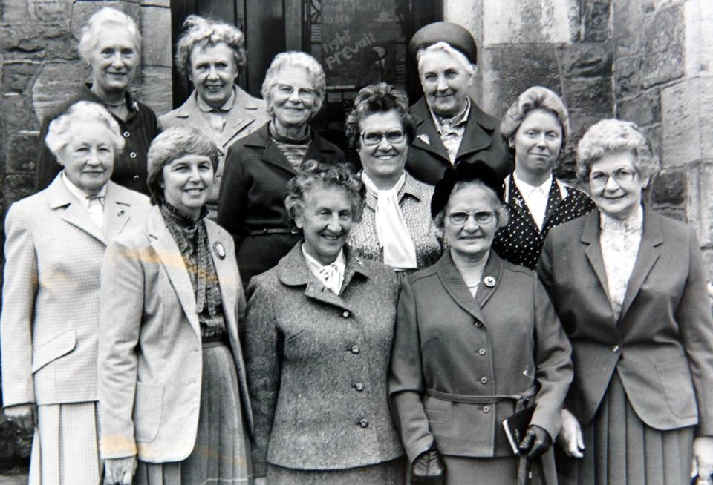
Back Row [L – R] - - - -? Miss Hazel Bell, Miss Kathleen James, Mrs Eva Moffitt, Mrs Maud McCord, Mrs Florence Johnston,
Front Row [L – R] Mrs Emma Wilson, Mrs Isa Carson, Mrs Doreen Russell,
Mrs May Johnston, Mrs Elizabeth Ewing
Photo No. 2: Omagh Bible Class with Eric Rainey [left]
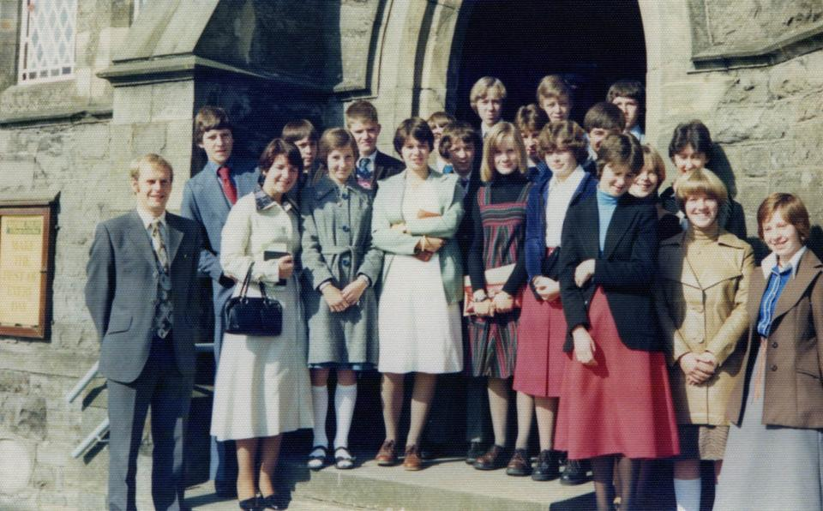

Photo No.3: Rev Edmund Mawhinney [right] President of the Methodist Church and Rev Clifford Taylor with members of Mayne Methodist Church
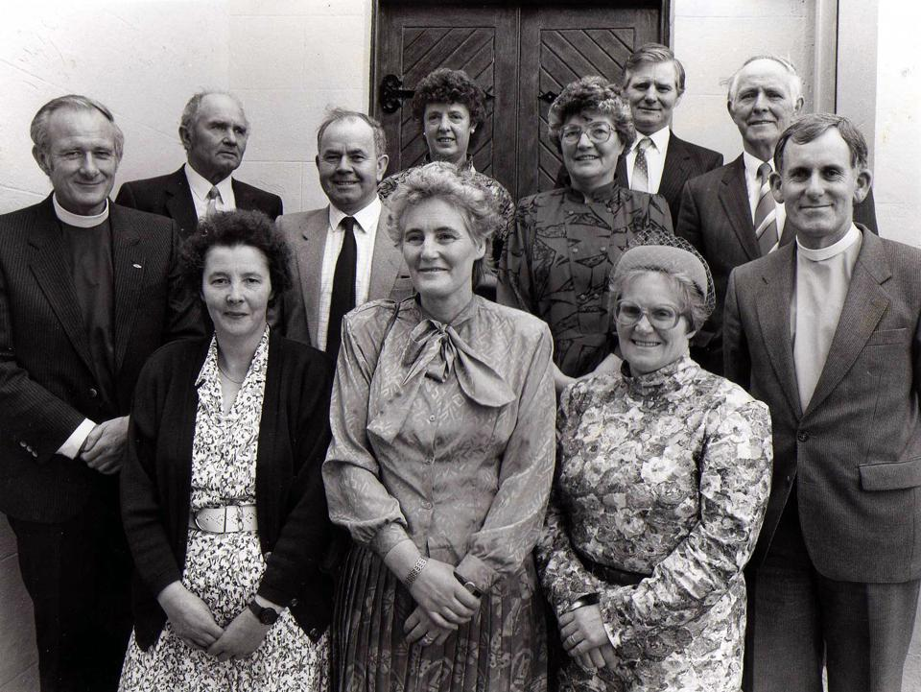
Photo No. 4: The choir which sang at the 125th Anniversary Service in Omagh Church
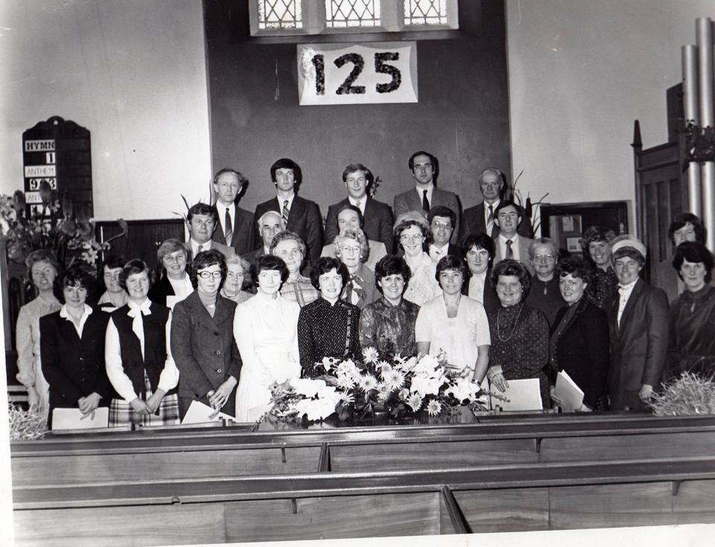
Front Row [L – R] Mary Montgomery, Rosemary Caldwell, Edith Warner, Kathleen Edwards, Lorna Thompson, Lorna Alcorn, Ray McClenaghan, Jean Armstrong, Paddy Abbott, Betty Doonan, Isobel Strong
2nd Row [L – R] Florence Johnston, Pam Mayers, Isa Carson, Roberta Gibson, Gladys Braden, Noreen Henderson, - - - -? Doreen Preston, Betty Thompson, Helen Kenwell, Ruth Alcorn
3rd Row [L – R] Dougie Turner, James Montgomery, Basil Henderson, Robert Thompson
4th Row [L – R] Archie Wood, Charles Kenwell, - - - -? Fred Kenwell, George Montgomery
Photo No. 5: Four members of Mayne church who were received into full membership
[L – R] William Hawkes, Victor Kelly, Ian Hawkes and Glen Hawkes
