Memories in photographs. Gerry Knight
It will not come as a surprise to those who know him that many of Gerry’s memories of Life in Omagh Methodist Church and around the circuit are stored in his albums of old photographs. Inspired by Sonia’s recollections of days gone by, Gerry has selected seven pictures from his archive.
Circuit Leaders Meeting
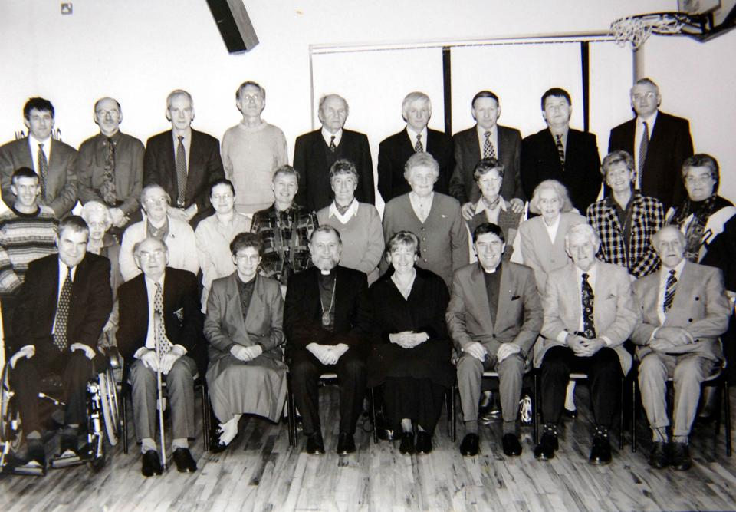
Sunday School
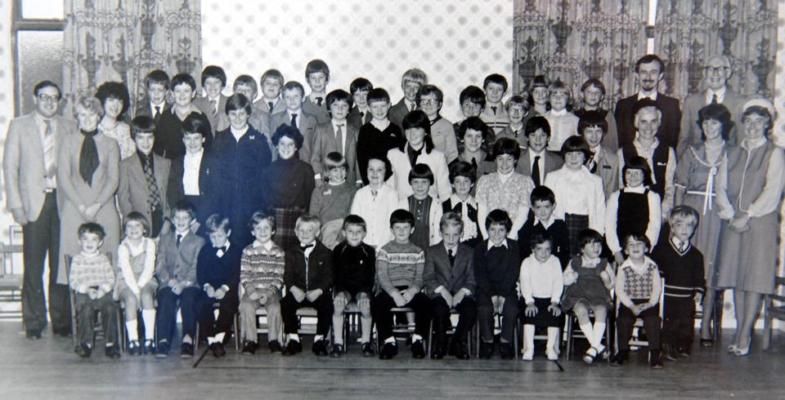
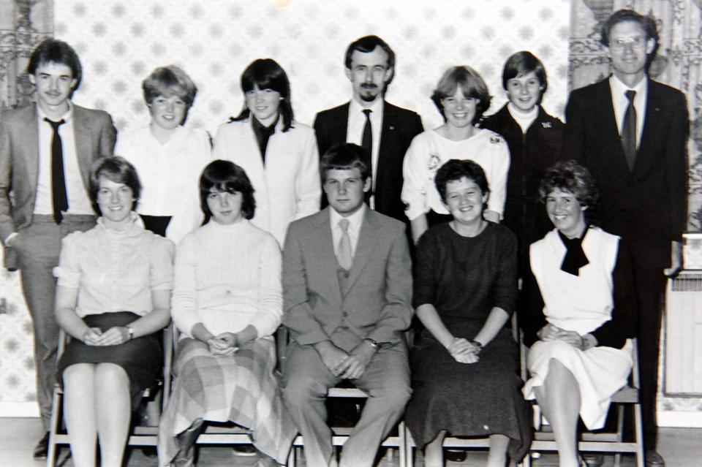
Reception Service
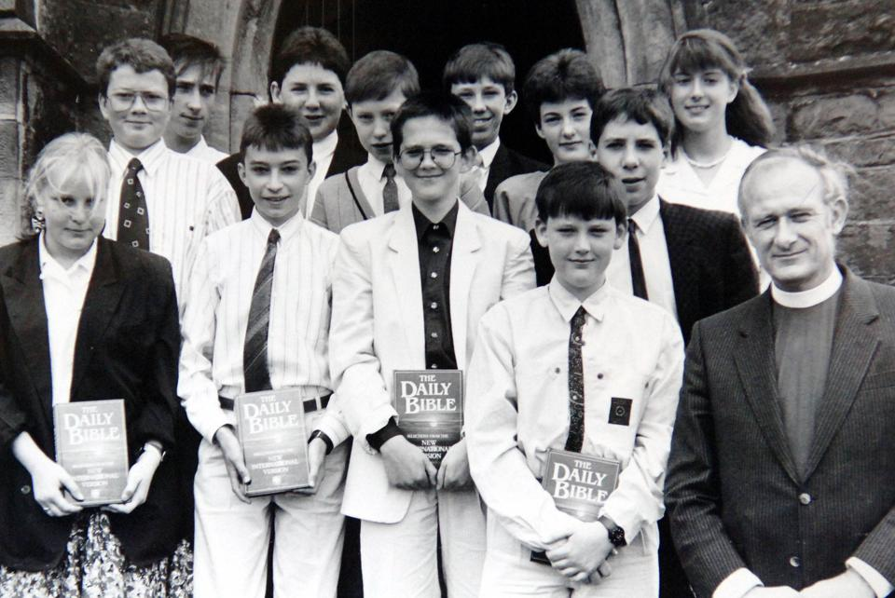

Reception Service
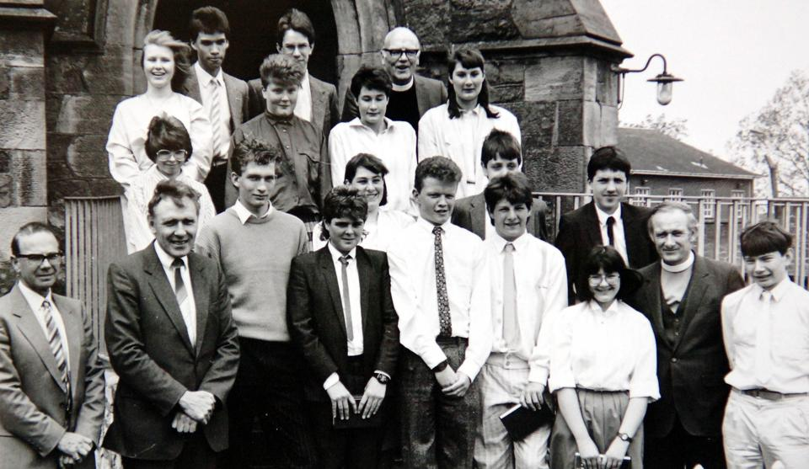
Sunday School
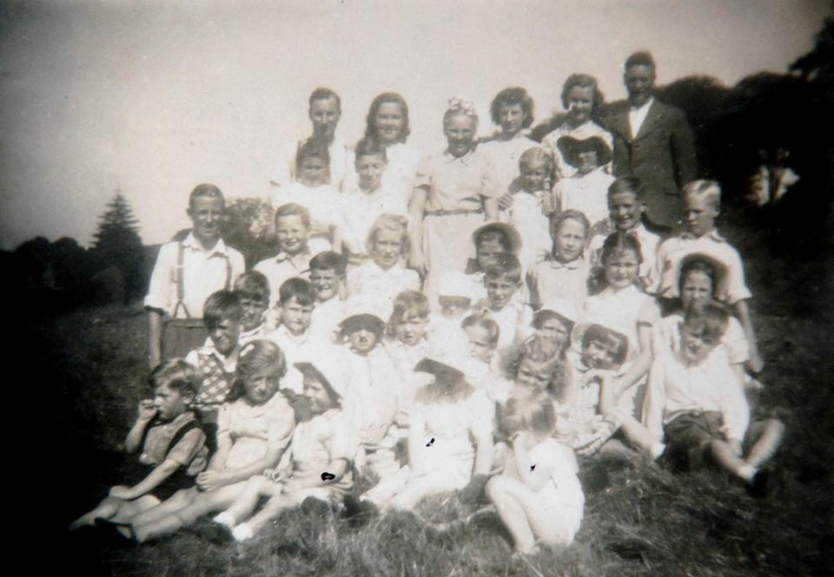
Sunday School in the Showgrounds
